**Trabajo Práctico 7 - Sistemas Operativos**

**Integrantes:**

* Borgogno, Francisco
* Cañas, Felipe
* Lucero Ruiz, Maximo
* Quesada, Santiago

**Profesor:** Funes, Gustavo

**1.**

| **tail -n +5 base.txt** |
| --- |

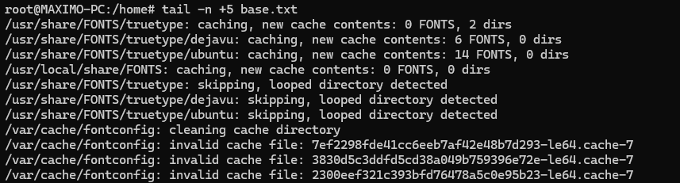

**2.**

| **grep -o 'extra' base.txt | wc -l** |
| --- |

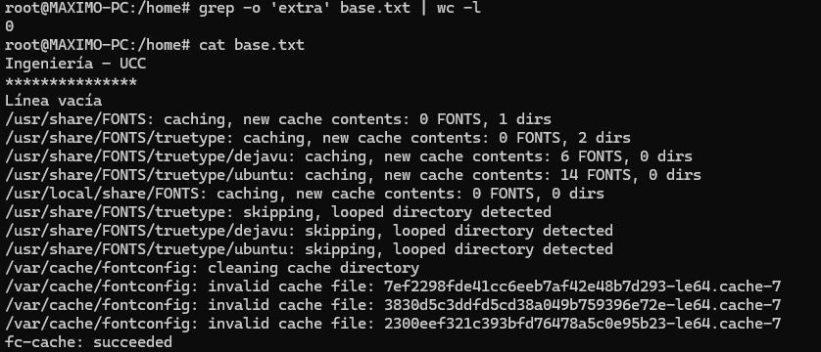

**3.**

| **echo -e "Pedro\nJuan\nAna\nPedro\nJuan\nAna" > amigos.txt** |
| --- |



**4.**

| **sort amigos.txt** |
| --- |

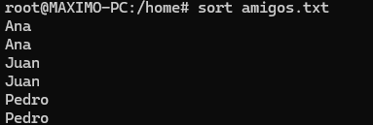

**5.**

| **sort amigos.txt | uniq** |
| --- |

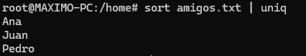

**6.**

| **echo -e "1 Pedro\n2 Juan\n3 Ana\n4 María\n5 José" > alumnos.txt echo -e "1 Coronda\n2 Cacheuta\n3 Paso de la Patria\n4 Langer\n5 Cruz Roja" > direcciones.txt** |
| --- |



**7.**

| **join alumnos.txt direcciones.txt > alumnos_direcciones.txt** |
| --- |

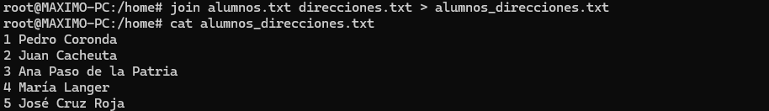

**8.**

| **cat /etc/passwd** |
| --- |

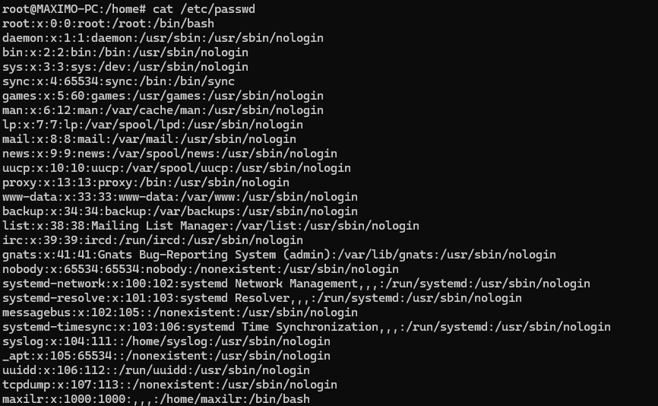

| **cut -d: -f1 /etc/passwd** |
| --- |

